|  |  |  |
| --- | --- | --- |
| Sprint review - **Increment four dELIVERY** | | |
|  | | |
| **Location:** | Google Meets |  |
| **Date:** | October 24, 2020 |  |
| **Time:** | **5:00 PM** |  |
| **Facilitator:** | Baheshta Abed |  |

# Attendees:

Mashall Addeel, Sayed Manshour Sadat, Masuoma Tajik and Mahdi Alizada.

**Meeting Purpose:**

The purpose of this meeting was for the Development Team to present the fourth increment for the Product Owner to either approve or reject or give feedback for any changes.

**Below are the events that took place in the meeting:**

In the opening note, the Scrum Master briefly explained the events that took place in the previous Sprint that lead to the finishing of this Increment, followed by the Development Team, presenting the project they have worked on, to the Product Owner.

During the Sprint, the Scrum Master did conduct Daily Sprints via Facebook Messenger, in order to keep a track of the tasks being done accurately based on the Product Owners’ demand (i.e. the user stories). Below are the Sprint Backlogs as well as the Burn Out Chart for the fourth Sprint.

|  |  |  |  |  |  |
| --- | --- | --- | --- | --- | --- |
| **Tasks** | **Hours** | **Day 1** | **Day 2** | **Day 3** | **Day 4** |
| Add a “Delete Option” for the Admin to be able to delete users | 4 | 4 |  |  |  |
| Design and create “List-view” for each category | 4 | 2 | 2 |  |  |
| Include “Print Option” for the materials in the system | 4 |  | 4 |  |  |
| Ensure the printing is legally allowed | 4 |  |  | 4 |  |
| Add a “Filter Option” for the materials in the system | 4 |  |  | 2 | 2 |
| **Total Hours:** | **20** | **6** | **6** | **6** | **2** |

Burn Out Chart



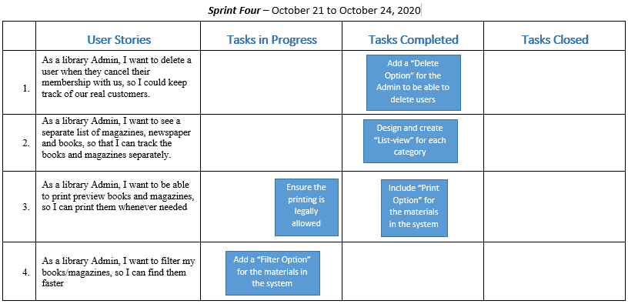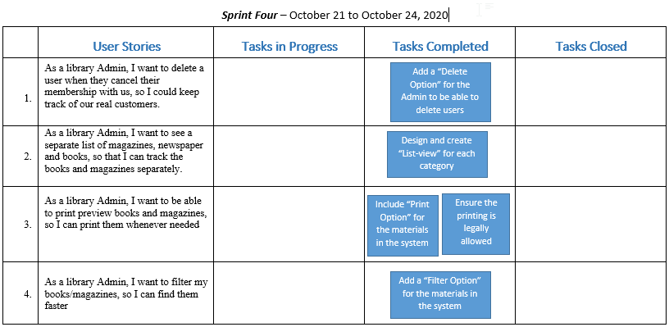

**Sprint Backlogs** were updated every day throughout the Sprint.

Day 2 of Sprint IV

Day 4 of Sprint IV

Once again, the Product Owner was pleased with the work of the overall work of the Development Team. The Product Owner, did give a few comments, which are as per usual to be fixed by and presented in the last Sprint Review. Furthermore, the Development Team delivered another successful increment and in the end of the meeting, the Product Owner asked the Team to go on and start with the fifth and last increment.

**Note:** The Product Owner only approved of the increment but did mention that the increments will need some work once it’s all put together.